Introduction

The Ar Yone Thit Health Care Training Center will provide the student with training opportunities of Nurse Assistant/Assistant Pharmacist subject such as Basic Level(Level A), Intermediate and Advance Level.

Eligibility for the Health Care class requires candidates to provide data on their professional and education background. The Information request in this document will remain confidential and used solely for the eligibility assessment purpose.
Applicant General Information
Name
Date Of Birth
Sex | Male Female
Religious
Ethnic Group(Race)
Marital Status
Email Address
Telephone Number
Contact Address
Permanent Address

Passport Number

Level of English Language

What is your level of proficiency in English Language(Oral and writhing)

Beginner | Intermediate | Pre  Intermediate | Advanced | Elementary | Don’t Know
Please tick your Level.

Applied Class

Level | Time | Day | Applying Subject
Basic Level | 8:00 Am To 12:00 Pm  or  1:00 PM To 4:00 PM  (*Please Tick one ) | 5 days 0r 6 days per week?
Intermediate Level |  | 5 days 0r 6 days per week?
Advance Level |  | 5 days 0r 6 days per week?
Please tick your preferable class /Time/Duration/Major Subject.

Are you also attending other classes/school/university?
Sr No | Name of class/school/university | Days | Time | Subject

Attending Purpose
( please write your purpose why you would like to attend the course) Myanmar or English language
--------------------------------------------------------------------------------------------------------------------------------------------------------------------------------------------------------------------------------------------------------------------------------------------------------------------------------------------------------------------------------------------------------------------------------------------------------------------------------------------------------------------------------------------------------------------------------------------------------------------------------------------------------------------------------------------------------------------------------------------------------------------------------------------------------------------------------------------------------------------------------------------------------------------------------------------------------------------------------------------------------------------------------------------------------------------------------------------------------------------------------------------------------------------------------------------------------------------------------------------------------------------------------------------------------------------------------------------------------------------------------------------------------------------------------------------------------------------------------------------------------------------------------------------------------------------------------------------------------------------------------------------------------------------------------------------------------------------------------------------------
Future Plan
Please very briefly describe your future plan as in what you will do after the class.
-----------------------------------------------------------------------------------------------------------------------------------------------------------------------------------------------------------------------------------------------------------------------------------------------------------------------------------------------------------------------------------------------------------------------------------------------------------------------------------------------------------------------------------------------------------------------------------------------------------------------------------------------------------------------------------------------------------------------------------------------------------------------------------------------------------------------------------------------------------------------------------------------------------------------------------------------------------------------------------------------------------------------------------------------------------------------------------------------------------------------------------------------------------------------------------------------------------------------------------------------------------------------------------------------------------------------------------------------------------------------------------------------------------------------------------------------------------------------------------------------------------------------------------------------------------------------------------------------------------------------------------------------------------------------------------------------------------------------------------------------------------------------------------------------------------------------------------------------------------------------------------------------------------------------------------------------------------------------------------------------------------------------------------------------------------------------------------------------------------------------------------------------------------------------------------------------------------------------------------------------------------------------------------------------------------------------------------------------------------------------------------------------------------------------------------------------------------------------------------------------------------------------------------------------------------------------------------------------------------------------------------------------------------------------------------------------------------------------------------------------------------------------------------------------------------------------------------------------------------------------------------------------------------------------------------------------------------------------------------------------------------------------------------------------------------
Referee

Include who we can refer to in your cases
(1)Name----------------------------------------------------------
Position ------------------------------------------- (Father/Mother/Uncle etc;)
Email address--------------------------------------------------
Telephone Number ------------------------------------------
Contact Address----------------------------------------------
Address ------------------------------------------------------------------------------------------------------------------------------------------------------------------------------------------------------------------------------------------------------------------------------------------------------------------------------------------------------------------------------------------

(2) Name----------------------------------------------------------
Position ------------------------------------------- (Father/Mother/Uncle etc;)
Email address--------------------------------------------------
Telephone Number ------------------------------------------
Contact Address----------------------------------------------
Address ------------------------------------------------------------------------------------------------------------------------------------------------------------------------------------------------------------------------------------------------------------------------------------------------------------------------------------------------------------------------------------------
Signature of applicant
I certify that my statement in answer to the foregoing question is true, complete and correct to the best of my knowledge and belief. If selected as a participant I undertaken to spend the time during the period of the Ar Yone Thit Health Care courses as directed by The Ar Yone Thit Health Care Training center .

Signature-----------------------------
Name --------------------------------
Date --------------------------------

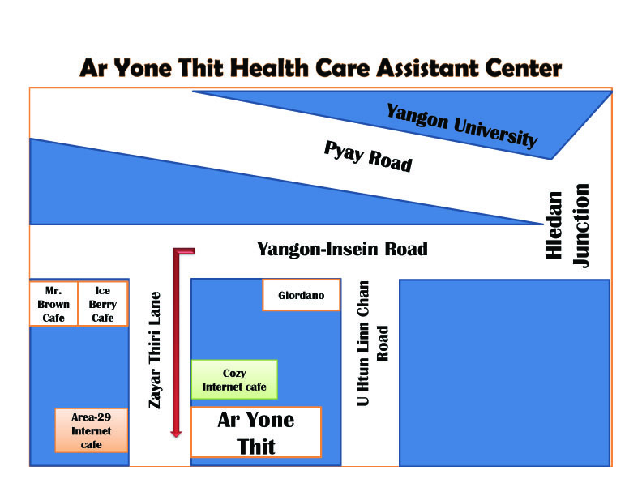
Ar Yone Thit Myanmar Social Worker Association
No 1 Room c/2, Zayar Thiti Lane,Yangon-Insein Road,Hledan Junction,Kamayut Township,Yangon,
Ph.0973031467(Office),0949230204,0943051677
Contact Person for information about Nurse Aid Course
Daw Soe Soe Lwin
Email
info.aryonethit@gmail.com,
aryonethitmswa@gmail.com
Website www.aryonethit.weebly.com

